ERROR ANALYSIS

Confusion matrix deep drive:

The cancer data set has 100 records, out of which 94 are cancer records and 6 are non-cancer records. But the model is predicting 90 out of 94 cancer records correctly. Four cancer records are not predicted correctly

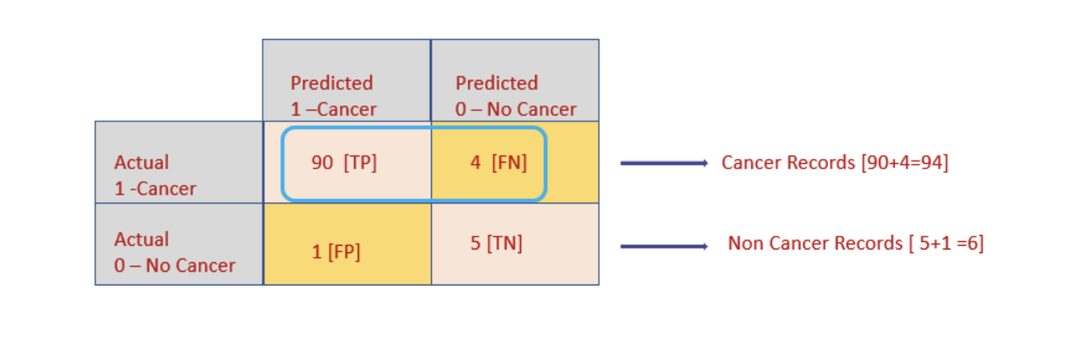
Recall = Out of all positive records, how many records are predicted correctly.
Precision = Out of all positives been predicted, how many are actually positive.

- In this example, recall metrics is more important than precision. The recall rate should be 100%. All positive records( cancer records) should be predicted correctly. False Negative should be 0.
- For this cancer dataset, recall metrics is given more importance while evaluating the performance of the model.
- If non-cancer records are predicted as cancer means it’s not that risky.

Business Cost of Errors:

False Negative (FN)
- Cancer patient diagnosed as healthy
- Disease progresses untreated
- Cost: EXTREME (life-threatening)

False Positive (FP)
- Healthy person flagged as cancer
- Extra tests, stress, cost
- Cost: Moderate
Assume:
- Missing cancer (FN) = ₹10,00,000 impact (treatment delay + life risk)
- False alarm (FP) = ₹10,000 (tests, stress)

Cost:
- FN cost = 1 × 10,00,000 = ₹10,00,000
- FP cost = 4 × 10,000 = ₹40,000

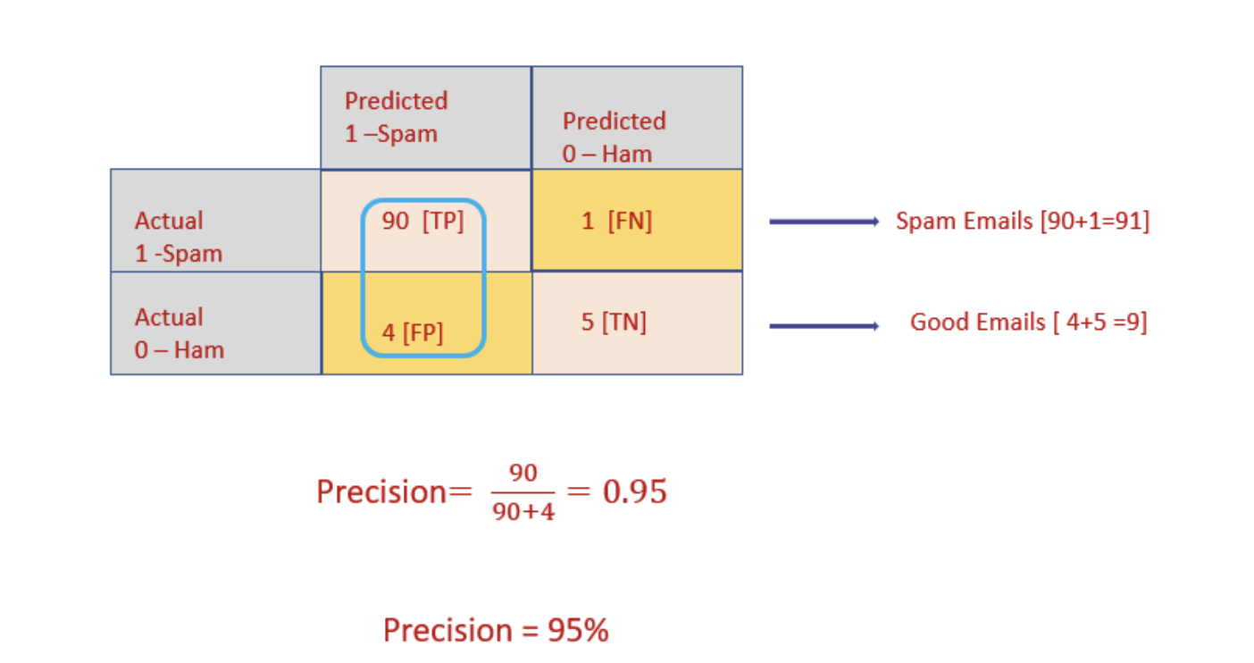
If the spam filtering dataset has 100 records, out of which 94 are predicted as spam emails. Only 90 out of 94 records is predicted correctly. 4 good emails are classified as spam. It’s risky. The precision rate is 95%. It should be 100%. No good emails should be classified as "Spam". False-positive should be 0 for this model.

Business Cost of Errors:

False Positive (FP)
- Legit email marked as spam
- Example: job offer, OTP, client message → gone to spam
- Cost: HIGH (missed opportunity, business loss)

False Negative (FN)
- Spam email reaches inbox
- Annoying, but user can ignore
- Cost: LOW
Assume:
- Missing important email (FP) = ₹5,000 loss
- Spam reaching inbox (FN) = ₹10 annoyance

Cost:
- FP cost = 1 × 5,000 = ₹5,000
- FN cost = 4 × 10 = ₹40

